SIMATS ENGINEERING (SAVEETHA SCHOOL OF ENGINEERING)
Department of Computer Science and Engineering
CO3 ASSESSMENT TOOL 1 – Git & Docker Technical Assignment

Course Code: | CSA1017 | Course Title: | Software Engineering
CO Assessed: | CO3 | Assessment: | Assessment Tool 1 – Git & Docker Technical Assignment
Weightage: | 20% | Total Marks: | 25
CO3 Statement: | Build full-stack applications with an emphasis on containerization, version control, and collaborative development
Student Name: | SHAKTHIVEL R | Reg. No.: | 192524325
Date: | 13-08-2026 | Duration: | 60 minutes

Code of Conduct
I SHAKTHIVEL R (192524325) certify that this submission is my original work and that I have adhered to the guidelines specified for this assessment. I understand that any violation of academic integrity rules will result in disciplinary action.
Signature of the Student: _________________________
Annexure A – Git & Docker Technical Assignment
Instructions to Students:
Each student has been assigned an individual problem statement. Based on the assigned problem statement, prepare a Git & Docker Technical Assignment by applying version control and containerization concepts. Your report should include appropriate diagrams, screenshots, commands, and explanations wherever applicable.

Assignment Questions
- Problem Analysis
  - Explain the assigned problem statement and identify the project objectives, functional requirements, and expected outcomes.
- Project Structure Design
  - Design and explain the folder structure of your project repository.
  - Justify the purpose of each major folder and file included in the repository.
- Git Repository Initialization
  - Create a Git repository for the project.
  - Explain the steps involved in repository initialization and describe the purpose of the essential Git files.
- Git Branching Strategy
  - Design a suitable branching strategy (e.g., Main, Development, Feature, Release, Hotfix).
  - Justify why the selected branching model is appropriate for the assigned project.
- Version Control Workflow
  - Demonstrate the Git workflow by performing meaningful commits, branch creation, merging, conflict resolution (if applicable), and repository synchronization.
  - Explain the purpose of each Git operation performed.
- Commit History Analysis
  - Present the commit history of the project.
  - Explain how commit messages follow good version control practices and contribute to project maintenance.
- Docker Environment Design
  - Explain why Docker is suitable for the assigned project.
  - Identify the application components that require containerization.
- Dockerfile Development
  - Design and explain the Dockerfile required to containerize the application.
  - Describe the purpose of each instruction used in the Dockerfile.
- Docker Compose Design
  - Develop a Docker Compose configuration for the project.
  - Explain the services, networking, volumes, environment variables, and dependencies used.
- Container Deployment and Testing
  - Demonstrate the execution of the application using Docker containers.
  - Explain the testing procedure and provide evidence that the application runs successfully.
- Benefits of Git and Docker
  - Discuss how Git and Docker improve collaboration, version management, portability, deployment, scalability, and maintainability for your assigned project.
- Challenges and Improvements
  - Identify the challenges encountered during implementation.
  - Suggest possible improvements and future enhancements for the Git workflow and Docker deployment.

Expected Deliverables
- Technical report (10 pages)
- Git repository with complete commit history
- Source code of the assigned project
- Dockerfile
- Docker Compose file (docker-compose.yml)
- Screenshots of Git operations and Docker execution
- Architecture and workflow diagrams

Rubrics for Calculation
Evaluation Criteria | Excellent (4 Marks) | Good (3 Marks) | Satisfactory (2 Marks) | Needs Improvement (1 Mark)
Problem Analysis & Project Design(20%) | Clearly explains the problem statement, objectives, requirements, expected outcomes, and well-organized project structure with proper justification. | Good analysis and project structure with minor omissions. | Basic analysis and repository structure with limited justification. | Incomplete or unclear analysis and project organization.
Git Repository & Branching Strategy(20%) | Repository initialized correctly with appropriate branching strategy, clear workflow, and proper repository organization. | Repository and branching strategy are mostly correct. | Basic Git setup with limited branching implementation. | Incorrect or incomplete Git repository and branching strategy.
Version Control Workflow & Commit History(10%) | Demonstrates meaningful commits, branching, merging, synchronization, conflict resolution, and professional commit messages with clear history. | Most Git operations demonstrated correctly with good commit history. | Limited Git workflow and commit practices. | Poor workflow and inadequate commit history.
Docker Implementation(20%) | Well-designed Docker environment, Dockerfile, and Docker Compose configuration with clear explanation of services, networking, volumes, and dependencies. | Functional Docker implementation with minor issues. | Basic Docker implementation with limited explanation. | Incomplete or incorrect Docker implementation.
Deployment, Testing & Results(15%) | Application successfully deployed and tested with appropriate screenshots and evidence of successful execution. | Deployment completed with minor issues. | Partial deployment and testing demonstrated. | Deployment unsuccessful or insufficient evidence.
Documentation, Challenges & Future Enhancements(15%) | Professional report (10–15 pages) with diagrams, screenshots, references, discussion of benefits, challenges, and future improvements. | Good documentation with minor omissions. | Basic documentation with limited discussion. | Poor documentation and insufficient analysis.

Criteria | Mark
System Requirement Analysis (30%) | /5
Selection of Software Architecture (25%) | /5
Architecture Diagram and Component Design (20%) | /5
Component Interaction and Quality Attribute Analysis (15%) | /5
Architectural Justification and Technical Presentation (10%) | /5
TOTAL | /25

1. PROBLEM ANALYSIS

1.1 Problem Statement
Aquaculture farms continuously depend on water-quality conditions, fish health, stocking density and timely feeding. Manual monitoring can delay identification of disease symptoms and can also lead to over-feeding or under-feeding. The proposed Intelligent AI-Based Smart Aquaculture Disease Prediction and Feed Optimization System combines sensor data, a machine-learning prediction module and a feed recommendation module to support faster and more consistent farm decisions.
The system receives water and farm observations such as temperature, pH, dissolved oxygen, turbidity, fish behaviour and recent feeding information. The data is validated and stored, then processed by an AI service that estimates disease risk. A feed-optimization component recommends an appropriate feeding quantity or schedule using current farm conditions. Results are presented through a dashboard so that a farmer or administrator can take action.

1.2 Project Objectives
• Monitor important aquaculture parameters and maintain a structured history of observations.
• Predict disease risk from water-quality and fish-related parameters.
• Recommend feed quantity and timing using current conditions and historical feeding data.
• Generate alerts when disease risk or abnormal water conditions exceed defined thresholds.
• Provide a modular full-stack design that can be maintained and deployed using Git and Docker.
• Improve portability and reproducibility by packaging application services as containers.

1.3 Functional Requirements
ID | Requirement | Description
FR1 | User access | Allow authorized users to view farm status and prediction results.
FR2 | Sensor data input | Receive or upload temperature, pH, dissolved oxygen and turbidity readings.
FR3 | Data validation | Check ranges, missing values and invalid sensor records before processing.
FR4 | Disease prediction | Calculate a disease-risk score using the trained AI model.
FR5 | Feed optimization | Generate a recommended feed amount/schedule from farm conditions.
FR6 | Alert generation | Notify users about high disease risk or critical water-quality values.
FR7 | History and reports | Store observations and predictions for later analysis.
2. PROJECT STRUCTURE DESIGN

2.1 Proposed Repository Structure
smart-aquaculture/
├── frontend/
│ ├── src/
│ ├── public/
│ └── package.json
├── backend/
│ ├── app/
│ │ ├── main.py
│ │ ├── routes/
│ │ ├── services/
│ │ └── schemas/
│ └── requirements.txt
├── ai-service/
│ ├── models/
│ ├── train.py
│ ├── predict.py
│ └── requirements.txt
├── database/
│ └── init.sql
├── tests/
│ ├── test_api.py
│ └── test_prediction.py
├── Dockerfile
├── docker-compose.yml
├── .dockerignore
├── .gitignore
└── README.md

2.2 Purpose of Major Folders and Files
Folder/File | Purpose
frontend/ | Contains the farmer/admin dashboard and user interface.
backend/ | Provides REST APIs, validation, authentication logic and application services.
ai-service/ | Contains model training/inference logic for disease prediction and feed optimization.
database/ | Stores SQL initialization scripts and database-related configuration.
tests/ | Contains automated tests for API endpoints and AI service behaviour.
Dockerfile | Defines the image-building instructions for the application environment.
docker-compose.yml | Defines multiple services, networking, environment variables and dependencies.
.gitignore | Prevents generated files, secrets, virtual environments and local artifacts from being committed.
.dockerignore | Reduces Docker build context by excluding unnecessary files.

2.3 Design Principles
• Separation of concerns: interface, API, AI processing and persistence are maintained as separate components.
• Modularity: each service can be modified or scaled without rewriting the entire application.
• Testability: business logic and prediction functions are separated so they can be tested independently.
• Configuration through environment variables: database credentials and runtime settings are not hard-coded.
• Repository cleanliness: generated files and secrets are excluded through .gitignore and .dockerignore.
This structure supports the CO3 requirement of collaborative development because multiple developers can work on frontend, backend and AI components in separate feature branches while integrating through a shared Git repository.

3. GIT REPOSITORY INITIALIZATION

3.1 Repository Initialization Steps
• Create the project folder and initialize Git using git init.
• Create the initial application folders, README.md and .gitignore.
• Stage the required files with git add .
• Create the first snapshot using a meaningful commit message.
• Connect the local repository to a remote Git hosting service.
• Push the main branch and use protected branch rules for controlled integration.
mkdir smart-aquaculture
cd smart-aquaculture
git init
git branch -M main
git add .
git commit -m "chore: initialize smart aquaculture project"
git remote add origin <REMOTE_REPOSITORY_URL>
git push -u origin main

3.2 Essential Git Files
File | Purpose
.git/ | Stores Git objects, references, configuration and repository history.
.gitignore | Prevents secrets, local environments, caches and generated files from entering version control.
README.md | Provides project setup, usage and contribution information.
.gitattributes | Can define line-ending and file-handling rules consistently across operating systems.

3.3 Recommended gitignore Entries
__pycache__/
*.pyc
.venv/
.env
node_modules/
dist/
build/
.pytest_cache/
*.log
The .env file is intentionally excluded because database passwords, API keys and other deployment secrets should not be stored in a public repository.

3.4 Repository Synchronization
git status
git pull --rebase origin main
git add .
git commit -m "feat: add water quality validation"
git push origin feature/water-validation
git status checks the working tree, git pull retrieves remote changes, git add stages changes, git commit records a versioned snapshot, and git push synchronizes a local branch with the remote repository.

4. GIT BRANCHING STRATEGY

4.1 Selected Strategy
A lightweight Git Flow-style strategy is selected for the project. The main branch contains stable code. The develop branch contains integrated development work. Individual features are implemented in short-lived feature branches. Release branches are used to stabilize a version, while hotfix branches address urgent defects discovered after release.
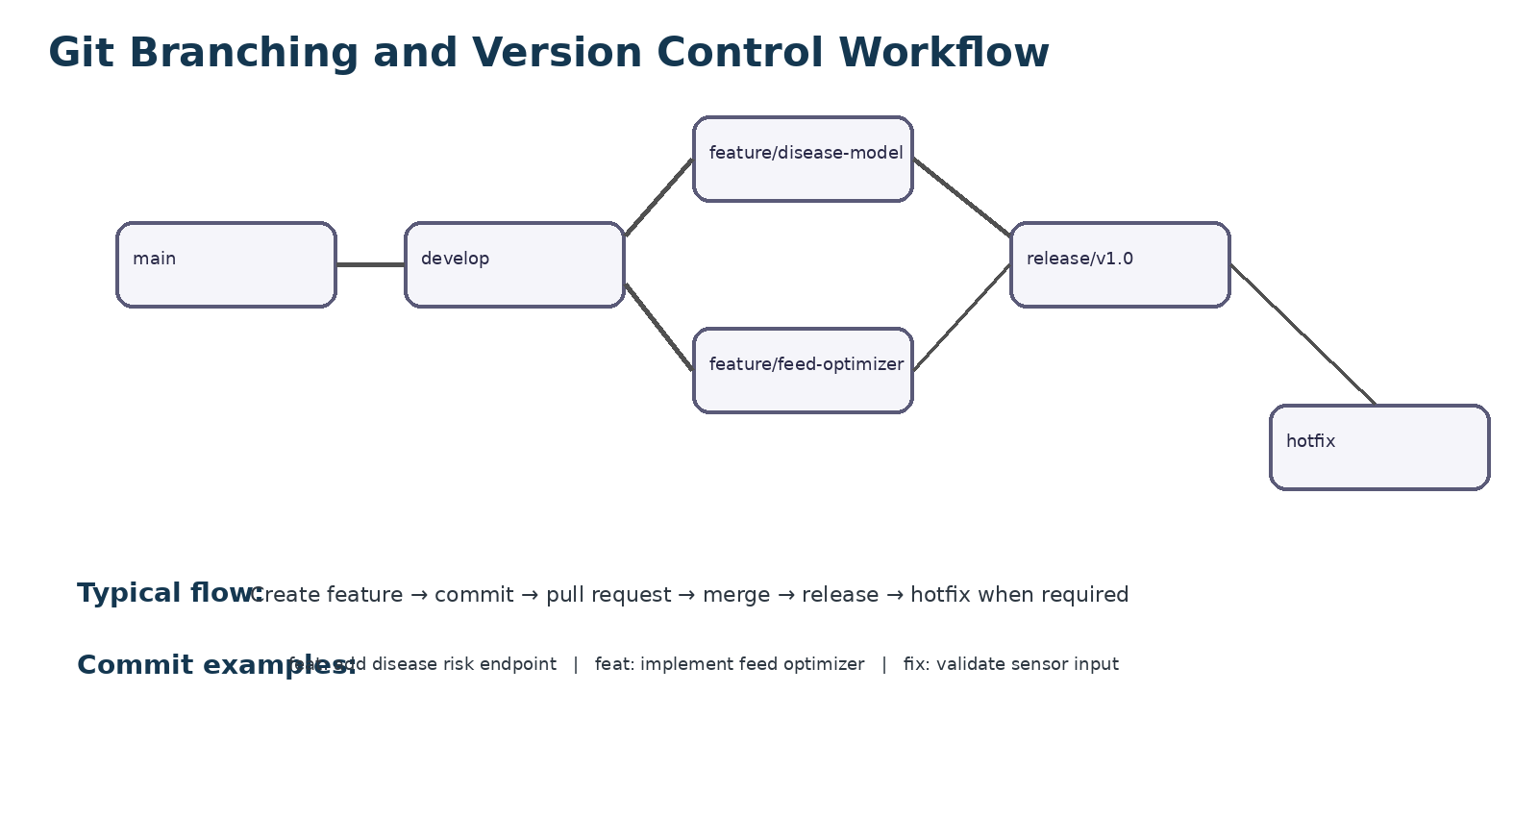
Figure 2. Proposed branching strategy for collaborative development.

4.2 Branch Naming Convention

Branch | Example | Purpose
main | main | Stable, release-ready code.
develop | develop | Integration branch for completed features.
feature | feature/disease-model | New functionality developed independently.
release | release/v1.0 | Final testing and stabilization before release.
hotfix | hotfix/water-alert | Urgent correction to production/release code.

4.3 Why This Strategy Fits the Project
• AI model development and dashboard development can proceed independently.
• Unfinished features are isolated from stable production code.
• Release branches provide a controlled testing stage for Docker deployment.
• Hotfixes can be applied quickly without disturbing unrelated development.
• Pull requests make code review and collaborative verification possible.
5. VERSION CONTROL WORKFLOW

5.1 Typical Development Workflow
git checkout develop
git pull origin develop
git checkout -b feature/disease-model
# edit files and run tests
git add backend/ ai-service/
git commit -m "feat: add disease risk prediction endpoint"
git push -u origin feature/disease-model
# create pull request and review changes
git checkout develop
git merge --no-ff feature/disease-model
git push origin develop

5.2 Meaningful Commit Examples

Commit Message | Purpose
feat: add sensor data endpoint | Adds a new functional capability.
feat: implement disease risk model | Introduces AI prediction functionality.
feat: add feed optimization service | Adds feed recommendation logic.
fix: validate invalid pH values | Corrects input validation behaviour.
test: add prediction service tests | Adds automated verification.
docs: update Docker setup | Improves project documentation.
chore: update dependencies | Updates non-functional project dependencies.

5.3 Merge Conflict Resolution
If two branches modify the same lines, Git may report a merge conflict. The developer should inspect the conflict markers, keep the correct combined logic, remove the markers, test the result and then commit the resolution.
git checkout develop
git merge feature/feed-optimizer
# resolve conflict in the affected file
git add <resolved-file>
git commit -m "fix: resolve feed optimizer merge conflict"
git push origin develop
Conflict resolution should be followed by application tests because a syntactically valid merge can still introduce incorrect behaviour.
6. COMMIT HISTORY ANALYSIS

6.1 Example Commit History

commit 7d91f3a feat: add feed optimization service
commit 4a82b1c feat: add disease risk prediction endpoint
commit 92f40e7 feat: add water quality validation
commit 61d18ac test: add API and prediction tests
commit 2e77a11 chore: add Docker Compose configuration
commit 0c5d2b9 chore: initialize smart aquaculture project
The above history is a proposed project history format for the technical report. In an actual repository, the displayed hashes and timestamps will be generated by Git. The key practice is to keep commits small, meaningful and related to one logical change.

6.2 Good Commit Message Practices
• Use an action-oriented prefix such as feat, fix, test, docs or chore.
• Keep each commit focused on one logical change.
• Explain what was changed rather than using vague messages such as update files.
• Commit working increments so that a previous stable state can be recovered.
• Use pull requests and review before merging important changes into develop or main.

6.3 Repository Maintenance
A clean history makes regression analysis easier. If a disease prediction result changes after a model update, the team can identify the commit that changed the inference code or model artifact. Git tags such as v1.0.0 can also identify stable releases that correspond to Docker image versions.

7. DOCKER ENVIRONMENT DESIGN

7.1 Why Docker Is Suitable
The proposed system contains several technologies: a web interface, backend API, AI inference logic and a database. Docker packages each runtime with its dependencies so the development, testing and deployment environments remain consistent. This reduces configuration differences between a developer laptop, a testing machine and a deployment server.

7.2 Components Requiring Containerization

Service | Responsibility | Container Benefit
web | Dashboard/UI | Provides a consistent web runtime.
api | REST API and validation | Packages Python dependencies and application configuration.
ai-worker | Disease prediction and feed optimization | Isolates machine-learning libraries and model runtime.
db | Persistent aquaculture data | Provides a reproducible database environment with a named volume.
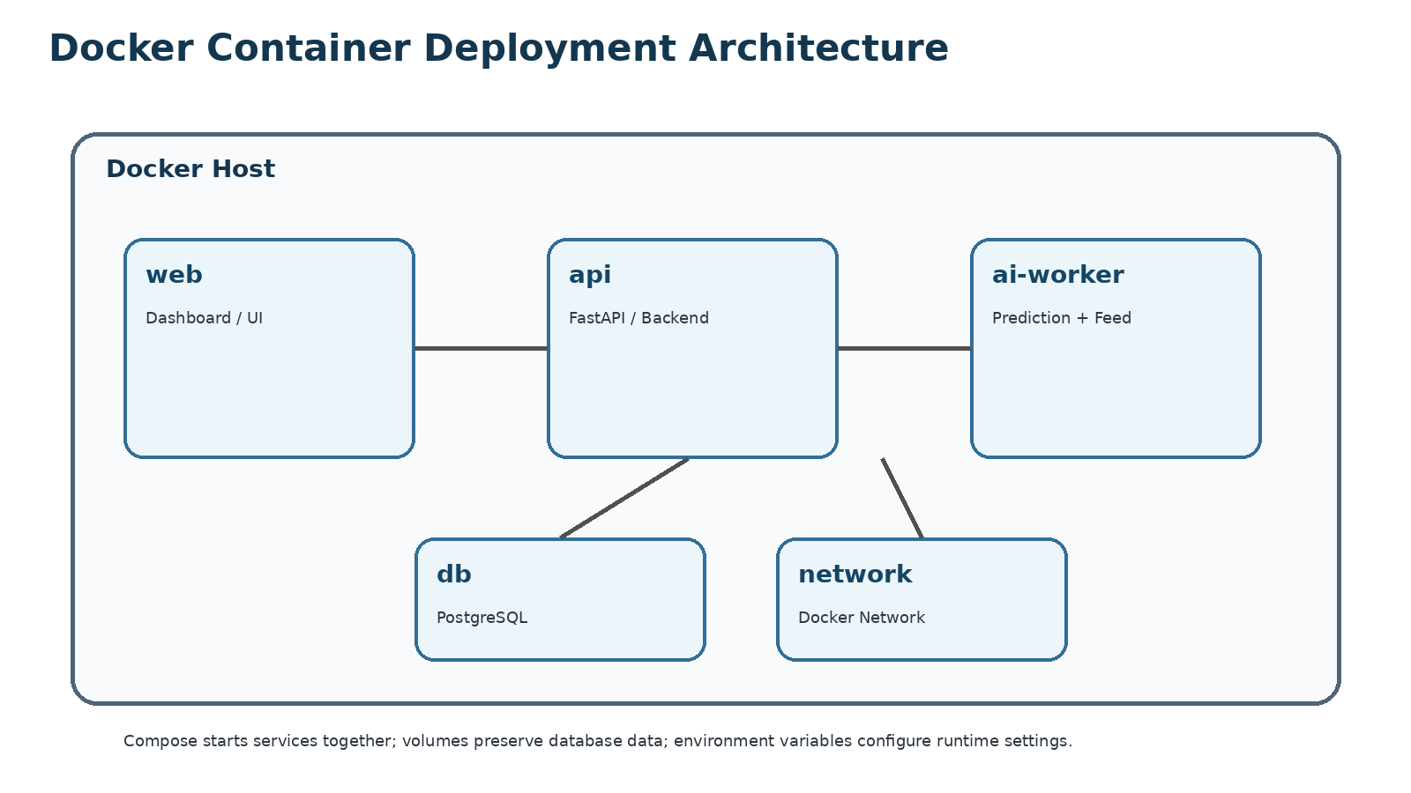
Figure 3. Docker container deployment architecture.

7.3 Docker Design Considerations
• Use environment variables for configuration rather than embedding secrets in images.
• Use a named volume for database persistence.
• Expose only the required application ports.
• Keep services on an internal Docker network for service-to-service communication.
• Build images from stable base images and update dependencies regularly.
8. DOCKERFILE DEVELOPMENT

8.1 Proposed Backend Dockerfile
FROM python:3.11-slim
WORKDIR /app
ENV PYTHONDONTWRITEBYTECODE=1
ENV PYTHONUNBUFFERED=1
COPY backend/requirements.txt ./requirements.txt
RUN pip install --no-cache-dir -r requirements.txt
COPY backend/ ./
EXPOSE 8000
CMD ["uvicorn", "app.main:app", "--host", "0.0.0.0", "--port", "8000"]

8.2 Explanation of Instructions
Instruction | Purpose
FROM | Selects the base Python runtime image.
WORKDIR | Sets the working directory inside the image.
ENV | Controls Python runtime behaviour.
COPY | Copies dependency and application files into the image.
RUN | Installs the required Python packages.
EXPOSE | Documents the port used by the API.
CMD | Starts the FastAPI application through Uvicorn.

8.3 Build and Run Commands
docker build -t smart-aqua-api:1.0 .
docker run --name smart-aqua-api -p 8000:8000 smart-aqua-api:1.0
docker ps
docker logs smart-aqua-api
The image should contain only what is required to run the service. A multi-stage build can be introduced later if a build process creates large intermediate artifacts.

9. DOCKER COMPOSE DESIGN

9.1 Proposed docker-compose.yml
services:
db:
image: postgres:16
environment:
POSTGRES_DB: aquaculture
POSTGRES_USER: aqua_user
POSTGRES_PASSWORD: ${DB_PASSWORD}
volumes:
- db_data:/var/lib/postgresql/data
networks: [aqua-net]
api:
build: .
environment:
DATABASE_URL: postgresql://aqua_user:${DB_PASSWORD}@db:5432/aquaculture
depends_on: [db]
ports:
- '8000:8000'
networks: [aqua-net]
ai-worker:
build: ./ai-service
depends_on: [db]
networks: [aqua-net]
volumes:
db_data:
networks:
aqua-net:

9.2 Services, Network, Volume and Dependency Design
Element | Design Decision | Reason
db service | PostgreSQL 16 | Structured storage for sensor readings, predictions and feed records.
api service | Custom application image | Provides REST endpoints and business logic.
ai-worker service | Custom AI image | Separates model dependencies from the API runtime.
aqua-net | Private Docker network | Allows containers to communicate by service name.
db_data | Named volume | Preserves database data when the container is recreated.
depends_on | api/AI depend on db | Expresses startup dependency between services.

9.3 Environment Variables
DB_PASSWORD=<strong-password>
API_ENV=production
MODEL_PATH=/models/disease_model.joblib
In a real deployment, secrets should be managed through a secure secret-management mechanism. The .env file should not be committed to Git.

10. CONTAINER DEPLOYMENT, TESTING AND RESULTS

10.1 Deployment Procedure
• Install Docker Desktop or Docker Engine on the target machine.
• Clone the Git repository and switch to the required release or main branch.
• Create the required environment variables without committing secrets.
• Build and start the services using Docker Compose.
• Check running containers and inspect logs.
• Open the API/dashboard endpoint and perform functional tests.
git clone <REMOTE_REPOSITORY_URL>
cd smart-aquaculture
docker compose build
docker compose up -d
docker compose ps
docker compose logs --tail=50
docker compose down

10.2 Functional Test Cases
ID | Test | Input/Action | Expected Result
TC01 | Valid water-quality input | API accepts record | Record stored and prediction generated
TC02 | Missing pH value | Validation rejects incomplete record | Clear validation error returned
TC03 | High disease-risk input | Prediction service evaluates risk | High-risk alert is generated
TC04 | Normal farm conditions | Prediction evaluates normal risk | No critical alert is produced
TC05 | Feed recommendation request | Optimizer receives valid farm data | Recommended feed quantity returned
TC06 | Database restart | Service restarts without data loss | Named volume preserves records
TC07 | Container health | docker compose ps | Required services remain running

10.3 Testing Evidence
For the final practical demonstration, screenshots should be captured from the student's own terminal and browser after execution. Recommended evidence includes: (1) git status and commit history, (2) docker compose ps showing running services, (3) docker compose logs, and (4) a browser/API response showing the application endpoint. The diagrams in this report are design illustrations and should not be presented as real execution screenshots.

10.4 Expected Result
After successful startup, the API container should listen on port 8000, the AI service should be available to the backend, and PostgreSQL should remain persistent through the named volume. A valid sensor record should move through validation, storage and prediction before the dashboard displays the result.

11. BENEFITS, CHALLENGES AND FUTURE ENHANCEMENTS

11.1 Benefits of Git
• Collaboration: developers can work on independent features without overwriting each other's changes.
• Version management: every meaningful change is recorded and can be reviewed or reverted.
• Traceability: commits connect implementation changes with project activities.
• Code review: pull requests support controlled integration.
• Release management: tags and release branches identify stable versions.

11.2 Benefits of Docker
• Portability: the same application image can be moved between compatible environments.
• Consistency: dependencies and runtime configuration are packaged with the service.
• Isolation: backend, AI and database components run in separate environments.
• Scalability: services can be replicated independently when demand increases.
• Maintainability: service boundaries make upgrades and troubleshooting easier.

11.3 Challenges
• Sensor data may contain missing, noisy or incorrect readings.
• AI prediction quality depends on representative and sufficiently labelled training data.
• Machine-learning dependencies can make images large and increase build time.
• Database credentials and model files must be protected during deployment.
• Distributed services require careful logging, health checks and dependency management.

11.4 Future Enhancements
• Integrate ESP32/IoT sensor nodes for real-time telemetry.
• Add continuous model retraining using verified disease observations.
• Introduce time-series forecasting for water-quality trends.
• Add role-based access control and audit logging.
• Use Docker health checks, CI/CD pipelines and automated image scanning.
• Deploy on a cloud platform with horizontal scaling and managed database services.
• Add mobile notifications for urgent disease-risk and water-quality alerts.

12. ARCHITECTURAL JUSTIFICATION AND QUALITY ATTRIBUTES

12.1 Selected Architecture
A modular service-oriented architecture is selected for the proposed system. The presentation layer communicates with the backend API, while the backend coordinates database operations and AI inference. Separating the AI worker is useful because machine-learning libraries and model execution can have different resource requirements from ordinary API requests.
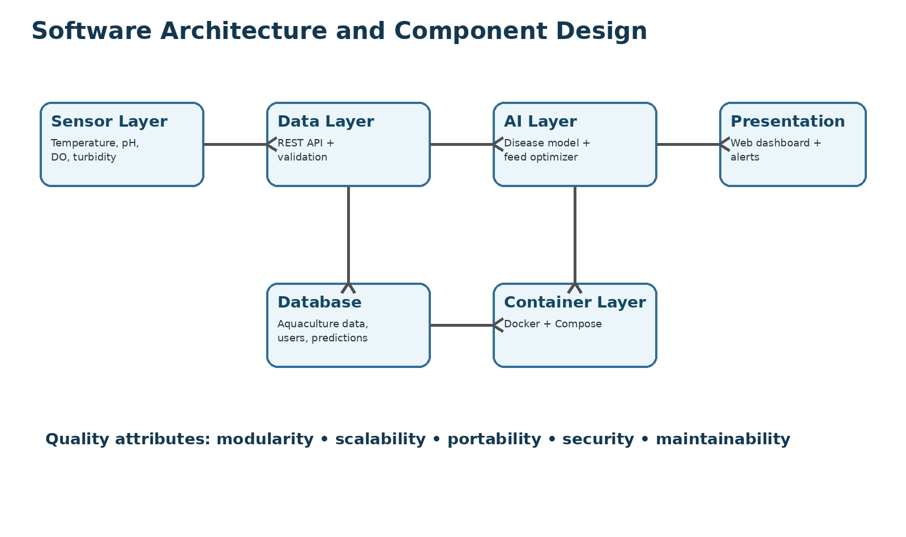
Figure 4. Component architecture for the proposed smart aquaculture platform.

12.2 Component Interaction
• 1. Sensors or farm operators provide observations such as temperature, pH, dissolved oxygen and turbidity.
• 2. The API validates the input and stores the observation in PostgreSQL.
• 3. The AI service reads the relevant features and produces disease-risk and feed-optimization outputs.
• 4. The backend stores prediction results and sends the response to the dashboard.
• 5. The dashboard presents status, recommendations and alerts to the user.

12.3 Quality Attribute Analysis

Quality Attribute | Design Approach | Expected Benefit
Scalability | Separate API and AI worker containers | AI inference can be scaled independently.
Availability | Container restart policies and health checks | Faster recovery from service failure.
Security | Environment variables, authentication and limited ports | Reduces exposure of secrets and services.
Maintainability | Modular folders and small Git commits | Changes are easier to isolate and review.
Portability | Docker images and Compose configuration | Consistent deployment across environments.
Testability | Separate API, service and prediction tests | Faults can be detected before release.

12.4 Architectural Justification
The design balances simplicity with future expansion. Separating the AI workload and database supports scale and maintainability, while Docker Compose provides practical local deployment.

12.5 Conclusion
The proposed Intelligent AI-Based Smart Aquaculture Disease Prediction and Feed Optimization System demonstrates how software engineering practices can be combined with AI and containerization for an aquaculture application. Git provides controlled collaboration and traceability, while Docker provides reproducible deployment for the frontend, API, AI and database components.
The modular design supports future integration of IoT sensors, improved machine-learning models, real-time alerts and cloud deployment. Combining version control, testing and containerization provides a maintainable foundation for a practical smart aquaculture platform.

12.6 References
• Git Documentation. Git Reference and User Manual. https://git-scm.com/docs
• Docker Documentation. Docker Engine and Docker Compose documentation. https://docs.docker.com/
• Python Software Foundation. Python Documentation. https://docs.python.org/3/
• FastAPI Documentation. FastAPI User Guide. https://fastapi.tiangolo.com/
• PostgreSQL Global Development Group. PostgreSQL Documentation. https://www.postgresql.org/docs/
• Scikit-learn Developers. Scikit-learn User Guide. https://scikit-learn.org/stable/user_guide.html
• FAO. The State of World Fisheries and Aquaculture. https://www.fao.org/sofia/

